**Name**: Vishal Shashikant Salvi.

**Class**: SE Comps

**Batch**: C

**UID**: 2019230069

**Experiment No 5**

**Aim**:

To create a basic e-commerce website which uses Bootstrap for major styling and basic functioning of pages.

**Theory:**

**What is Bootstrap?**

Bootstrap is a powerful front-end framework for faster and easier web development. It includes HTML and CSS based design templates for creating common user interface components like forms, buttons, navigations, dropdowns, alerts, modals, tabs, accordions, carousels, tooltips, and so on.

**What You Can Do with Bootstrap**

There are lot more things you can do with Bootstrap.

• You can easily create responsive websites.

• You can quickly create multi-column layout with pre-defined classes.

• You can quickly create different types of form layouts.

• You can quickly create different variation of navigation bar.

• You can easily create components like accordions, modals, etc. without writing any JS code.

• You can easily create dynamic tabs to manage large amount of content.

• You can easily create tooltips and popovers to show hint text.

• You can easily create carousel or image slider to showcase your content.

• You can quickly create different types of alert boxes.

**Advantages of Using Bootstrap**

If you have had some experience with any front-end framework, you might be wondering what makes

Bootstrap so special. Here are some advantages why one should opt for Bootstrap framework:

• Save lots of time— You can save lots of time and efforts using the Bootstrap predefined design templates and classes and concentrate on other development work.

• Responsive features— Using Bootstrap you can easily create responsive websites that appear

more appropriately on different devices and screen resolutions without any change in markup.

• Consistent design— All Bootstrap components share the same design templates and styles

through a central library, so the design and layout of your web pages will be consistent.

• Easy to use— Bootstrap is very easy to use. Anybody with the basic working knowledge of

HTML, CSS and JavaScript can start development with Bootstrap.

• Compatible with browsers— Bootstrap is created with modern web browsers in mind and it is compatible with all modern browsers such as Chrome, Firefox, Safari, Internet Explorer, etc.

• Open Source— And the best part is, it is completely free to download and use.

Bootstrap Example:

<div class="jumbotron text-center">  
  <h1>My First Bootstrap Page</h1>  
  <p>Resize this responsive page to see the effect!</p>  
</div>  
  
<div class="container">  
  <div class="row">  
    <div class="col-sm-4">  
      <h3>Column 1</h3>  
      <p>Lorem ipsum dolor..</p>  
    </div>  
    <div class="col-sm-4">  
      <h3>Column 2</h3>  
      <p>Lorem ipsum dolor..</p>  
    </div>  
    <div class="col-sm-4">  
      <h3>Column 3</h3>  
      <p>Lorem ipsum dolor..</p>  
    </div>  
  </div>  
</div>

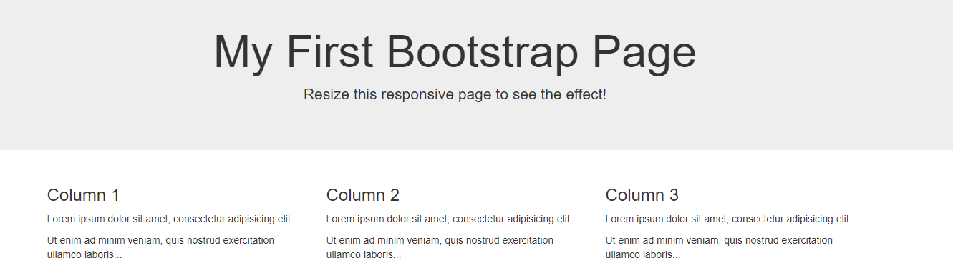

**Code**:

**Index.html**

<!DOCTYPE html>

<html lang="en">

<head>

    <meta charset="UTF-8">

    <meta name="viewport" content="width=device-width, initial-scale=1.0">

    <title>E-Commerce Website</title>

    <link rel="stylesheet" href="styles.css">

    <link rel="stylesheet" href="https://stackpath.bootstrapcdn.com/bootstrap/4.4.1/css/bootstrap.min.css">

    <link rel="stylesheet" href="https://stackpath.bootstrapcdn.com/font-awesome/4.7.0/css/font-awesome.min.css">

    <script src="https://code.jquery.com/jquery-3.4.1.slim.min.js"></script>

    <script src="https://stackpath.bootstrapcdn.com/bootstrap/4.4.1/js/bootstrap.min.js"></script>

</head>

<body>

    <nav class="navbar navbar-expand-lg navbar-dark bg-dark">

        <a class="navbar-brand col-sm-1" href="index.html" data-toggle="tooltip" data-placement="bottom" title="View homepage">

            <img src="images/logo.jpg" width="60" height="60" class="d-inline-block align-top" alt="logo image">

        </a>

        <div class="col-sm-5"></div>

        <form class="form-inline form-margin col-sm-3">

            <input class="form-control mr-sm-2" type="search" placeholder="Search" aria-label="Search">

            <button class="btn btn-outline-info my-2 my-sm-0" type="submit"><i class="fa fa-search"></i></button>

        </form>

        <ul class="navbar-nav col-sm-3">

            <li class="nav-item col-sm-4">

                <a class="nav-link" href="#cart"><i class="fa fa-shopping-basket"></i>Cart</a>

            </li>

            <li class="nav-item col-sm-4">

                <a class="nav-link" href="#signup">Sign Up</a>

            </li>

            <li class="nav-item col-sm-4">

                <a class="nav-link" href="#login">Log In</a>

            </li>

        </ul>

    </nav>

    <ul class="nav nav-tabs">

        <li class="nav-item col">

            <a href="#Pencil" class="nav-link active" data-toggle="tab">Pencil</a>

        </li>

        <li class="nav-item col">

            <a href="#Books" class="nav-link" data-toggle="tab">Books</a>

        </li>

        <li class="nav-item col">

            <a href="#Tiffin" class="nav-link" data-toggle="tab">Tiffin</a>

        </li>

    </ul>

    <div class="tab-content">

        <div class="tab-pane fade show active" id="Pencil">

            <!-- Write the entire content of Pencil page -->

            <nav aria-label="breadcrumb">

                <ol class="breadcrumb">

                    <li class="breadcrumb-item">Home</li>

                    <li class="breadcrumb-item active" aria-current="page">Pencil</li>

                </ol>

            </nav>

            <div class="container">

                <div id="carouselExampleIndicators" class="carousel slide my-4" data-ride="carousel">

                    <ol class="carousel-indicators">

                        <li data-target="#carouselExampleIndicators" data-slide-to="0" class="active"></li>

                        <li data-target="#carouselExampleIndicators" data-slide-to="1"></li>

                        <li data-target="#carouselExampleIndicators" data-slide-to="2"></li>

                    </ol>

                    <div style="width: 1100px; height: 550px;border-color: black;" class="carousel-inner" role="listbox" >

                        <div class="carousel-item active">

                            <img src="images/Colorp2.png" alt="First slide">

                        </div>

                        <div class="carousel-item">

                            <img src="images/Colorp3.png" alt="Second slide">

                        </div>

                        <div class="carousel-item">

                            <img src="images/Colorp1.png" alt="Third slide">

                        </div>

                    </div>

                    <a class="carousel-control-prev" href="#carouselExampleIndicators" role="button" data-slide="prev">

                        <span class="carousel-control-prev-icon" aria-hidden="true"></span>

                        <span class="sr-only">Previous</span>

                    </a>

                    <a class="carousel-control-next" href="#carouselExampleIndicators" role="button" data-slide="next">

                        <span class="carousel-control-next-icon" aria-hidden="true"></span>

                        <span class="sr-only">Next</span>

                    </a>

                </div>

                <div class="title-box">

                    <h2>Sale Sale!!!</h2>

                </div>

                <div class="row">

                    <div class="col-lg-4 col-md-6 mb-4">

                        <div class="card h-100">

                            <a href="Pencil.html"><img class="card-img-top" data-toggle="tooltip" data-placement="bottom" title="Click the view product page" src="images/pencil 1.jpeg" alt=""></a>

                            <div class="card-body">

                                <button type="button" class="btn btn-primary">Item 1 <span class="badge badge-light">100</span><span class="sr-only">in stock</span></button>

                                <h5>$25</h5>

                                <p class="card-text">Let us pick up our books and pencils. They are our most powerful weapon.</p>

                            </div>

                            <div class="card-footer">

                                <table class="table table-striped">

                                    <tbody>

                                        <tr>

                                            <td><small class="text-muted">&#9733; &#9733; &#9733; &#9733; &#9733;</small></td>

                                            <td>

                                                <div class="progress">

                                                    <div class="progress-bar" role="progressbar" style="width: 75%" aria-valuenow="75" aria-valuemin="0" aria-valuemax="100"></div>

                                                </div>

                                            </td>

                                        </tr>

                                        <tr>

                                            <td><small class="text-muted">&#9733; &#9733; &#9733; &#9734; &#9734;</small></td>

                                            <td>

                                                <div class="progress">

                                                    <div class="progress-bar" role="progressbar" style="width: 50%" aria-valuenow="50" aria-valuemin="0" aria-valuemax="100"></div>

                                                </div>

                                            </td>

                                        </tr>

                                        <tr>

                                            <td><small class="text-muted">&#9733; &#9733; &#9733; &#9733; &#9734;</small></td>

                                            <td>

                                                <div class="progress">

                                                    <div class="progress-bar" role="progressbar" style="width: 25%" aria-valuenow="25" aria-valuemin="0" aria-valuemax="100"></div>

                                                </div>

                                            </td>

                                        </tr>

                                    </tbody>

                                </table>

                            </div>

                        </div>

                    </div>

                    <div class="col-lg-4 col-md-6 mb-4">

                        <div class="card h-100">

                            <a href="Pencil.html"><img class="card-img-top" data-toggle="tooltip" data-placement="bottom" title="Click the view product page" src="images/Pencil 2.jpg" alt=""></a>

                            <div class="card-body">

                                <button type="button" class="btn btn-primary">Item 2 <span class="badge badge-light">100</span><span class="sr-only">in stock</span></button>

                                <h5>$15</h5>

                                <p class="card-text">Let us pick up our books and pencils. They are our most powerful weapon.</p>

                            </div>

                            <div class="card-footer">

                                <table class="table table-striped">

                                    <tbody>

                                        <tr>

                                            <td><small class="text-muted">&#9733; &#9733; &#9733; &#9733; &#9733;</small></td>

                                            <td>

                                                <div class="progress">

                                                    <div class="progress-bar" role="progressbar" style="width: 75%" aria-valuenow="75" aria-valuemin="0" aria-valuemax="100"></div>

                                                </div>

                                            </td>

                                        </tr>

                                        <tr>

                                            <td><small class="text-muted">&#9733; &#9733; &#9733; &#9734; &#9734;</small></td>

                                            <td>

                                                <div class="progress">

                                                    <div class="progress-bar" role="progressbar" style="width: 50%" aria-valuenow="50" aria-valuemin="0" aria-valuemax="100"></div>

                                                </div>

                                            </td>

                                        </tr>

                                        <tr>

                                            <td><small class="text-muted">&#9733; &#9733; &#9733; &#9733; &#9734;</small></td>

                                            <td>

                                                <div class="progress">

                                                    <div class="progress-bar" role="progressbar" style="width: 25%" aria-valuenow="25" aria-valuemin="0" aria-valuemax="100"></div>

                                                </div>

                                            </td>

                                        </tr>

                                    </tbody>

                                </table>

                            </div>

                        </div>

                    </div>

                    <div class="col-lg-4 col-md-6 mb-4">

                        <div class="card h-100">

                            <a href="Pencil.html"><img class="card-img-top" data-toggle="tooltip" data-placement="bottom" title="Click the view product page" src="images/Pencil 3.jpeg" alt=""></a>

                            <div class="card-body">

                                <button type="button" class="btn btn-primary">Item 3 <span class="badge badge-light">100</span><span class="sr-only">in stock</span></button>

                                <h5>$20</h5>

                                <p class="card-text">Let us pick up our books and pencils. They are our most powerful weapon.</p>

                            </div>

                            <div class="card-footer">

                                <table class="table table-striped">

                                    <tbody>

                                        <tr>

                                            <td><small class="text-muted">&#9733; &#9733; &#9733; &#9733; &#9733;</small></td>

                                            <td>

                                                <div class="progress">

                                                    <div class="progress-bar" role="progressbar" style="width: 75%" aria-valuenow="75" aria-valuemin="0" aria-valuemax="100"></div>

                                                </div>

                                            </td>

                                        </tr>

                                        <tr>

                                            <td><small class="text-muted">&#9733; &#9733; &#9733; &#9734; &#9734;</small></td>

                                            <td>

                                                <div class="progress">

                                                    <div class="progress-bar" role="progressbar" style="width: 50%" aria-valuenow="50" aria-valuemin="0" aria-valuemax="100"></div>

                                                </div>

                                            </td>

                                        </tr>

                                        <tr>

                                            <td><small class="text-muted">&#9733; &#9733; &#9733; &#9733; &#9734;</small></td>

                                            <td>

                                                <div class="progress">

                                                    <div class="progress-bar" role="progressbar" style="width: 25%" aria-valuenow="25" aria-valuemin="0" aria-valuemax="100"></div>

                                                </div>

                                            </td>

                                        </tr>

                                    </tbody>

                                </table>

                            </div>

                        </div>

                    </div>

                </div>

                <div class="title-box">

                    <h2>New Arrivals</h2>

                </div>

                <div class="row">

                    <div class="col-lg-4 col-md-6 mb-4">

                        <div class="card h-100">

                            <a href="Pencil.html"><img class="card-img-top" data-toggle="tooltip" data-placement="bottom" title="Click the view product page" src="images/Pencil 4.jpg" alt=""></a>

                            <div class="card-body">

                                <button type="button" class="btn btn-primary">Item 4 <span class="badge badge-light">100</span><span class="sr-only">in stock</span></button>

                                <h5>$25</h5>

                                <p class="card-text">Let us pick up our books and pencils. They are our most powerful weapon.</p>

                            </div>

                            <div class="card-footer">

                                <table class="table table-striped">

                                    <tbody>

                                        <tr>

                                            <td><small class="text-muted">&#9733; &#9733; &#9733; &#9733; &#9733;</small></td>

                                            <td>

                                                <div class="progress">

                                                    <div class="progress-bar" role="progressbar" style="width: 75%" aria-valuenow="75" aria-valuemin="0" aria-valuemax="100"></div>

                                                </div>

                                            </td>

                                        </tr>

                                        <tr>

                                            <td><small class="text-muted">&#9733; &#9733; &#9733; &#9734; &#9734;</small></td>

                                            <td>

                                                <div class="progress">

                                                    <div class="progress-bar" role="progressbar" style="width: 50%" aria-valuenow="50" aria-valuemin="0" aria-valuemax="100"></div>

                                                </div>

                                            </td>

                                        </tr>

                                        <tr>

                                            <td><small class="text-muted">&#9733; &#9733; &#9733; &#9733; &#9734;</small></td>

                                            <td>

                                                <div class="progress">

                                                    <div class="progress-bar" role="progressbar" style="width: 25%" aria-valuenow="25" aria-valuemin="0" aria-valuemax="100"></div>

                                                </div>

                                            </td>

                                        </tr>

                                    </tbody>

                                </table>

                            </div>

                        </div>

                    </div>

                    <div class="col-lg-4 col-md-6 mb-4">

                        <div class="card h-100">

                            <a href="Pencil.html"><img class="card-img-top" data-toggle="tooltip" data-placement="bottom" title="Click the view product page" src="images/Pencil 5.webp" alt=""></a>

                            <div class="card-body">

                                <button type="button" class="btn btn-primary">Item 5 <span class="badge badge-light">100</span><span class="sr-only">in stock</span></button>

                                <h5>$10</h5>

                                <p class="card-text">Let us pick up our books and pencils. They are our most powerful weapon.</p>

                            </div>

                            <div class="card-footer">

                                <table class="table table-striped">

                                    <tbody>

                                        <tr>

                                            <td><small class="text-muted">&#9733; &#9733; &#9733; &#9733; &#9733;</small></td>

                                            <td>

                                                <div class="progress">

                                                    <div class="progress-bar" role="progressbar" style="width: 75%" aria-valuenow="75" aria-valuemin="0" aria-valuemax="100"></div>

                                                </div>

                                            </td>

                                        </tr>

                                        <tr>

                                            <td><small class="text-muted">&#9733; &#9733; &#9733; &#9734; &#9734;</small></td>

                                            <td>

                                                <div class="progress">

                                                    <div class="progress-bar" role="progressbar" style="width: 50%" aria-valuenow="50" aria-valuemin="0" aria-valuemax="100"></div>

                                                </div>

                                            </td>

                                        </tr>

                                        <tr>

                                            <td><small class="text-muted">&#9733; &#9733; &#9733; &#9733; &#9734;</small></td>

                                            <td>

                                                <div class="progress">

                                                    <div class="progress-bar" role="progressbar" style="width: 25%" aria-valuenow="25" aria-valuemin="0" aria-valuemax="100"></div>

                                                </div>

                                            </td>

                                        </tr>

                                    </tbody>

                                </table>

                            </div>

                        </div>

                    </div>

                    <div class="col-lg-4 col-md-6 mb-4">

                        <div class="card h-100">

                            <a href="Pencil.html"><img class="card-img-top" data-toggle="tooltip" data-placement="bottom" title="Click the view product page" src="images/Pencil 6.jpg" alt=""></a>

                            <div class="card-body">

                                <button type="button" class="btn btn-primary">Item 6 <span class="badge badge-light">100</span><span class="sr-only">in stock</span></button>

                                <h5>$15</h5>

                                <p class="card-text">Let us pick up our books and pencils. They are our most powerful weapon.</p>

                            </div>

                            <div class="card-footer">

                                <table class="table table-striped">

                                    <tbody>

                                        <tr>

                                            <td><small class="text-muted">&#9733; &#9733; &#9733; &#9733; &#9733;</small></td>

                                            <td>

                                                <div class="progress">

                                                    <div class="progress-bar" role="progressbar" style="width: 75%" aria-valuenow="75" aria-valuemin="0" aria-valuemax="100"></div>

                                                </div>

                                            </td>

                                        </tr>

                                        <tr>

                                            <td><small class="text-muted">&#9733; &#9733; &#9733; &#9734; &#9734;</small></td>

                                            <td>

                                                <div class="progress">

                                                    <div class="progress-bar" role="progressbar" style="width: 50%" aria-valuenow="50" aria-valuemin="0" aria-valuemax="100"></div>

                                                </div>

                                            </td>

                                        </tr>

                                        <tr>

                                            <td><small class="text-muted">&#9733; &#9733; &#9733; &#9733; &#9734;</small></td>

                                            <td>

                                                <div class="progress">

                                                    <div class="progress-bar" role="progressbar" style="width: 25%" aria-valuenow="25" aria-valuemin="0" aria-valuemax="100"></div>

                                                </div>

                                            </td>

                                        </tr>

                                    </tbody>

                                </table>

                            </div>

                        </div>

                    </div>

                </div>

            </div>

        </div>

        <div class="tab-pane fade" id="Books">

            <!-- <p>Write the entire content of Books page</p> -->

            <nav aria-label="breadcrumb">

                <ol class="breadcrumb">

                    <li class="breadcrumb-item">Home</li>

                    <li class="breadcrumb-item active" aria-current="page">Books</li>

                </ol>

            </nav>

            <div class="container">

                <div id="carouselExampleIndicators1" class="carousel slide my-4" data-ride="carousel">

                    <ol class="carousel-indicators">

                        <li data-target="#carouselExampleIndicators1" data-slide-to="0" class="active"></li>

                        <li data-target="#carouselExampleIndicators1" data-slide-to="1"></li>

                        <li data-target="#carouselExampleIndicators1" data-slide-to="2"></li>

                    </ol>

                    <div style="width: 1100px; height: 550px;border-color: black;" class="carousel-inner" role="listbox">

                        <div class="carousel-item active">

                            <img src="images/Book7.png" alt="First slide">

                        </div>

                        <div class="carousel-item">

                            <img src="images/Book8.png" alt="Second slide">

                        </div>

                        <div class="carousel-item">

                            <img src="images/Book9.png" alt="Third slide">

                        </div>

                    </div>

                    <a class="carousel-control-prev" href="#carouselExampleIndicators1" role="button" data-slide="prev">

                        <span class="carousel-control-prev-icon" aria-hidden="true"></span>

                        <span class="sr-only">Previous</span>

                    </a>

                    <a class="carousel-control-next" href="#carouselExampleIndicators1" role="button" data-slide="next">

                        <span class="carousel-control-next-icon" aria-hidden="true"></span>

                        <span class="sr-only">Next</span>

                    </a>

                </div>

                <div class="title-box">

                    <h2>Sale Sale!!!</h2>

                </div>

                <div class="row">

                    <div class="col-lg-4 col-md-6 mb-4">

                        <div class="card h-100">

                            <a href="Books.html"><img class="card-img-top" data-toggle="tooltip" data-placement="bottom" title="Click the view product page" src="images/Book1.jpg" alt=""></a>

                            <div class="card-body">

                                <button type="button" class="btn btn-primary">Item 1 <span class="badge badge-light">100</span><span class="sr-only">in stock</span></button>

                                <h5>$30</h5>

                                <p class="card-text">A book that helps a child read the most frequently used words that are provided in the early first grade and set them into short easy-reading sentences. Presented in a very attractive and child-friendly manner, this book will become the best companion of every little learner.</p>

                            </div>

                            <div class="card-footer">

                                <table class="table table-striped">

                                    <tbody>

                                        <tr>

                                            <td><small class="text-muted">&#9733; &#9733; &#9733; &#9733; &#9733;</small></td>

                                            <td>

                                                <div class="progress">

                                                    <div class="progress-bar" role="progressbar" style="width: 75%" aria-valuenow="75" aria-valuemin="0" aria-valuemax="100"></div>

                                                </div>

                                            </td>

                                        </tr>

                                        <tr>

                                            <td><small class="text-muted">&#9733; &#9733; &#9733; &#9734; &#9734;</small></td>

                                            <td>

                                                <div class="progress">

                                                    <div class="progress-bar" role="progressbar" style="width: 50%" aria-valuenow="50" aria-valuemin="0" aria-valuemax="100"></div>

                                                </div>

                                            </td>

                                        </tr>

                                        <tr>

                                            <td><small class="text-muted">&#9733; &#9733; &#9733; &#9733; &#9734;</small></td>

                                            <td>

                                                <div class="progress">

                                                    <div class="progress-bar" role="progressbar" style="width: 25%" aria-valuenow="25" aria-valuemin="0" aria-valuemax="100"></div>

                                                </div>

                                            </td>

                                        </tr>

                                    </tbody>

                                </table>

                            </div>

                        </div>

                    </div>

                    <div class="col-lg-4 col-md-6 mb-4">

                        <div class="card h-100">

                            <a href="Books.html"><img class="card-img-top" data-toggle="tooltip" data-placement="bottom" title="Click the view product page" src="images/Book2.jpeg" alt=""></a>

                            <div class="card-body">

                                <button type="button" class="btn btn-primary">Item 2 <span class="badge badge-light">100</span><span class="sr-only">in stock</span></button>

                                <h5>$20</h5>

                                <p class="card-text">A book that helps a child read the most frequently used words that are provided in the early first grade and set them into short easy-reading sentences. Presented in a very attractive and child-friendly manner, this book will become the best companion of every little learner.</p>

                            </div>

                            <div class="card-footer">

                                <table class="table table-striped">

                                    <tbody>

                                        <tr>

                                            <td><small class="text-muted">&#9733; &#9733; &#9733; &#9733; &#9733;</small></td>

                                            <td>

                                                <div class="progress">

                                                    <div class="progress-bar" role="progressbar" style="width: 75%" aria-valuenow="75" aria-valuemin="0" aria-valuemax="100"></div>

                                                </div>

                                            </td>

                                        </tr>

                                        <tr>

                                            <td><small class="text-muted">&#9733; &#9733; &#9733; &#9734; &#9734;</small></td>

                                            <td>

                                                <div class="progress">

                                                    <div class="progress-bar" role="progressbar" style="width: 50%" aria-valuenow="50" aria-valuemin="0" aria-valuemax="100"></div>

                                                </div>

                                            </td>

                                        </tr>

                                        <tr>

                                            <td><small class="text-muted">&#9733; &#9733; &#9733; &#9733; &#9734;</small></td>

                                            <td>

                                                <div class="progress">

                                                    <div class="progress-bar" role="progressbar" style="width: 25%" aria-valuenow="25" aria-valuemin="0" aria-valuemax="100"></div>

                                                </div>

                                            </td>

                                        </tr>

                                    </tbody>

                                </table>

                            </div>

                        </div>

                    </div>

                    <div class="col-lg-4 col-md-6 mb-4">

                        <div class="card h-100">

                            <a href="Books.html"><img class="card-img-top" data-toggle="tooltip" data-placement="bottom" title="Click the view product page" src="images/Book3.jpg" alt=""></a>

                            <div class="card-body">

                                <button type="button" class="btn btn-primary">Item 3 <span class="badge badge-light">100</span><span class="sr-only">in stock</span></button>

                                <h5>$28</h5>

                                <p class="card-text">A book that helps a child read the most frequently used words that are provided in the early first grade and set them into short easy-reading sentences. Presented in a very attractive and child-friendly manner, this book will become the best companion of every little learner.</p>

                            </div>

                            <div class="card-footer">

                                <table class="table table-striped">

                                    <tbody>

                                        <tr>

                                            <td><small class="text-muted">&#9733; &#9733; &#9733; &#9733; &#9733;</small></td>

                                            <td>

                                                <div class="progress">

                                                    <div class="progress-bar" role="progressbar" style="width: 75%" aria-valuenow="75" aria-valuemin="0" aria-valuemax="100"></div>

                                                </div>

                                            </td>

                                        </tr>

                                        <tr>

                                            <td><small class="text-muted">&#9733; &#9733; &#9733; &#9734; &#9734;</small></td>

                                            <td>

                                                <div class="progress">

                                                    <div class="progress-bar" role="progressbar" style="width: 50%" aria-valuenow="50" aria-valuemin="0" aria-valuemax="100"></div>

                                                </div>

                                            </td>

                                        </tr>

                                        <tr>

                                            <td><small class="text-muted">&#9733; &#9733; &#9733; &#9733; &#9734;</small></td>

                                            <td>

                                                <div class="progress">

                                                    <div class="progress-bar" role="progressbar" style="width: 25%" aria-valuenow="25" aria-valuemin="0" aria-valuemax="100"></div>

                                                </div>

                                            </td>

                                        </tr>

                                    </tbody>

                                </table>

                            </div>

                        </div>

                    </div>

                </div>

                <div class="title-box">

                    <h2>New Arrivals</h2>

                </div>

                <div class="row">

                    <div class="col-lg-4 col-md-6 mb-4">

                        <div class="card h-100">

                            <a href="Books.html"><img class="card-img-top" data-toggle="tooltip" data-placement="bottom" title="Click the view product page" src="images/Book4.jpg" alt=""></a>

                            <div class="card-body">

                                <button type="button" class="btn btn-primary">Item 4 <span class="badge badge-light">100</span><span class="sr-only">in stock</span></button>

                                <h5>$40</h5>

                                <p class="card-text">A book that helps a child read the most frequently used words that are provided in the early first grade and set them into short easy-reading sentences. Presented in a very attractive and child-friendly manner, this book will become the best companion of every little learner.</p>

                            </div>

                            <div class="card-footer">

                                <table class="table table-striped">

                                    <tbody>

                                        <tr>

                                            <td><small class="text-muted">&#9733; &#9733; &#9733; &#9733; &#9733;</small></td>

                                            <td>

                                                <div class="progress">

                                                    <div class="progress-bar" role="progressbar" style="width: 75%" aria-valuenow="75" aria-valuemin="0" aria-valuemax="100"></div>

                                                </div>

                                            </td>

                                        </tr>

                                        <tr>

                                            <td><small class="text-muted">&#9733; &#9733; &#9733; &#9734; &#9734;</small></td>

                                            <td>

                                                <div class="progress">

                                                    <div class="progress-bar" role="progressbar" style="width: 50%" aria-valuenow="50" aria-valuemin="0" aria-valuemax="100"></div>

                                                </div>

                                            </td>

                                        </tr>

                                        <tr>

                                            <td><small class="text-muted">&#9733; &#9733; &#9733; &#9733; &#9734;</small></td>

                                            <td>

                                                <div class="progress">

                                                    <div class="progress-bar" role="progressbar" style="width: 25%" aria-valuenow="25" aria-valuemin="0" aria-valuemax="100"></div>

                                                </div>

                                            </td>

                                        </tr>

                                    </tbody>

                                </table>

                            </div>

                        </div>

                    </div>

                    <div class="col-lg-4 col-md-6 mb-4">

                        <div class="card h-100">

                            <a href="Books.html"><img class="card-img-top" data-toggle="tooltip" data-placement="bottom" title="Click the view product page" src="images/Book5.jpg" alt=""></a>

                            <div class="card-body">

                                <button type="button" class="btn btn-primary">Item 5 <span class="badge badge-light">100</span><span class="sr-only">in stock</span></button>

                                <h5>$36</h5>

                                <p class="card-text">A book that helps a child read the most frequently used words that are provided in the early first grade and set them into short easy-reading sentences. Presented in a very attractive and child-friendly manner, this book will become the best companion of every little learner.</p>

                            </div>

                            <div class="card-footer">

                                <table class="table table-striped">

                                    <tbody>

                                        <tr>

                                            <td><small class="text-muted">&#9733; &#9733; &#9733; &#9733; &#9733;</small></td>

                                            <td>

                                                <div class="progress">

                                                    <div class="progress-bar" role="progressbar" style="width: 75%" aria-valuenow="75" aria-valuemin="0" aria-valuemax="100"></div>

                                                </div>

                                            </td>

                                        </tr>

                                        <tr>

                                            <td><small class="text-muted">&#9733; &#9733; &#9733; &#9734; &#9734;</small></td>

                                            <td>

                                                <div class="progress">

                                                    <div class="progress-bar" role="progressbar" style="width: 50%" aria-valuenow="50" aria-valuemin="0" aria-valuemax="100"></div>

                                                </div>

                                            </td>

                                        </tr>

                                        <tr>

                                            <td><small class="text-muted">&#9733; &#9733; &#9733; &#9733; &#9734;</small></td>

                                            <td>

                                                <div class="progress">

                                                    <div class="progress-bar" role="progressbar" style="width: 25%" aria-valuenow="25" aria-valuemin="0" aria-valuemax="100"></div>

                                                </div>

                                            </td>

                                        </tr>

                                    </tbody>

                                </table>

                            </div>

                        </div>

                    </div>

                    <div class="col-lg-4 col-md-6 mb-4">

                        <div class="card h-100">

                            <a href="Books.html"><img class="card-img-top" data-toggle="tooltip" data-placement="bottom" title="Click the view product page" src="images/Book6.jpeg" alt=""></a>

                            <div class="card-body">

                                <button type="button" class="btn btn-primary">Item 6 <span class="badge badge-light">100</span><span class="sr-only">in stock</span></button>

                                <h5>$45</h5>

                                <p class="card-text">A book that helps a child read the most frequently used words that are provided in the early first grade and set them into short easy-reading sentences. Presented in a very attractive and child-friendly manner, this book will become the best companion of every little learner.</p>

                            </div>

                            <div class="card-footer">

                                <table class="table table-striped">

                                    <tbody>

                                        <tr>

                                            <td><small class="text-muted">&#9733; &#9733; &#9733; &#9733; &#9733;</small></td>

                                            <td>

                                                <div class="progress">

                                                    <div class="progress-bar" role="progressbar" style="width: 75%" aria-valuenow="75" aria-valuemin="0" aria-valuemax="100"></div>

                                                </div>

                                            </td>

                                        </tr>

                                        <tr>

                                            <td><small class="text-muted">&#9733; &#9733; &#9733; &#9734; &#9734;</small></td>

                                            <td>

                                                <div class="progress">

                                                    <div class="progress-bar" role="progressbar" style="width: 50%" aria-valuenow="50" aria-valuemin="0" aria-valuemax="100"></div>

                                                </div>

                                            </td>

                                        </tr>

                                        <tr>

                                            <td><small class="text-muted">&#9733; &#9733; &#9733; &#9733; &#9734;</small></td>

                                            <td>

                                                <div class="progress">

                                                    <div class="progress-bar" role="progressbar" style="width: 25%" aria-valuenow="25" aria-valuemin="0" aria-valuemax="100"></div>

                                                </div>

                                            </td>

                                        </tr>

                                    </tbody>

                                </table>

                            </div>

                        </div>

                    </div>

                </div>

            </div>

        </div>

        <div class="tab-pane fade" id="Tiffin">

            <!-- <p>Write the entire content of Tiffin page</p> -->

            <nav aria-label="breadcrumb">

                <ol class="breadcrumb">

                    <li class="breadcrumb-item">Home</li>

                    <li class="breadcrumb-item active" aria-current="page">Tiffin</li>

                </ol>

            </nav>

            <div class="container">

                <div id="carouselExampleIndicators2" class="carousel slide my-4" data-ride="carousel">

                    <ol class="carousel-indicators">

                        <li data-target="#carouselExampleIndicators2" data-slide-to="0" class="active"></li>

                        <li data-target="#carouselExampleIndicators2" data-slide-to="1"></li>

                        <li data-target="#carouselExampleIndicators2" data-slide-to="2"></li>

                    </ol>

                    <div style="width: 1100px; height: 550px;border-color: black;" class="carousel-inner" role="listbox">

                        <div class="carousel-item active">

                            <img src="images/Tiffin7.png" alt="First slide">

                        </div>

                        <div class="carousel-item">

                            <img src="images/Tiffin8.png" alt="Second slide">

                        </div>

                        <div class="carousel-item">

                            <img src="images/Tiffin9.png" alt="Third slide">

                        </div>

                    </div>

                    <a class="carousel-control-prev" href="#carouselExampleIndicators2" role="button" data-slide="prev">

                        <span class="carousel-control-prev-icon" aria-hidden="true"></span>

                        <span class="sr-only">Previous</span>

                    </a>

                    <a class="carousel-control-next" href="#carouselExampleIndicators2" role="button" data-slide="next">

                        <span class="carousel-control-next-icon" aria-hidden="true"></span>

                        <span class="sr-only">Next</span>

                    </a>

                </div>

                <div class="title-box">

                    <h2>Sale Sale!!!</h2>

                </div>

                <div class="row">

                    <div class="col-lg-4 col-md-6 mb-4">

                        <div class="card h-100">

                            <a href="Tiffin.html"><img class="card-img-top" data-toggle="tooltip" data-placement="bottom" title="Click the view product page" src="images/Tiffin1.jpeg" alt=""></a>

                            <div class="card-body">

                                <button type="button" class="btn btn-primary">Item 1 <span class="badge badge-light">100</span><span class="sr-only">in stock</span></button>

                                <h5>$32</h5>

                                <p class="card-text">For others it was just to eat at lunch break;For him it was a way to make friends on the first day of school.</p>

                            </div>

                            <div class="card-footer">

                                <table class="table table-striped">

                                    <tbody>

                                        <tr>

                                            <td><small class="text-muted">&#9733; &#9733; &#9733; &#9733; &#9733;</small></td>

                                            <td>

                                                <div class="progress">

                                                    <div class="progress-bar" role="progressbar" style="width: 75%" aria-valuenow="75" aria-valuemin="0" aria-valuemax="100"></div>

                                                </div>

                                            </td>

                                        </tr>

                                        <tr>

                                            <td><small class="text-muted">&#9733; &#9733; &#9733; &#9734; &#9734;</small></td>

                                            <td>

                                                <div class="progress">

                                                    <div class="progress-bar" role="progressbar" style="width: 50%" aria-valuenow="50" aria-valuemin="0" aria-valuemax="100"></div>

                                                </div>

                                            </td>

                                        </tr>

                                        <tr>

                                            <td><small class="text-muted">&#9733; &#9733; &#9733; &#9733; &#9734;</small></td>

                                            <td>

                                                <div class="progress">

                                                    <div class="progress-bar" role="progressbar" style="width: 25%" aria-valuenow="25" aria-valuemin="0" aria-valuemax="100"></div>

                                                </div>

                                            </td>

                                        </tr>

                                    </tbody>

                                </table>

                            </div>

                        </div>

                    </div>

                    <div class="col-lg-4 col-md-6 mb-4">

                        <div class="card h-100">

                            <a href="Tiffin.html"><img class="card-img-top" data-toggle="tooltip" data-placement="bottom" title="Click the view product page" src="images/Tiffin2.jpg" alt=""></a>

                            <div class="card-body">

                                <button type="button" class="btn btn-primary">Item 2 <span class="badge badge-light">100</span><span class="sr-only">in stock</span></button>

                                <h5>$10</h5>

                                <p class="card-text">For others it was just to eat at lunch break;For him it was a way to make friends on the first day of school.</p>

                            </div>

                            <div class="card-footer">

                                <table class="table table-striped">

                                    <tbody>

                                        <tr>

                                            <td><small class="text-muted">&#9733; &#9733; &#9733; &#9733; &#9733;</small></td>

                                            <td>

                                                <div class="progress">

                                                    <div class="progress-bar" role="progressbar" style="width: 75%" aria-valuenow="75" aria-valuemin="0" aria-valuemax="100"></div>

                                                </div>

                                            </td>

                                        </tr>

                                        <tr>

                                            <td><small class="text-muted">&#9733; &#9733; &#9733; &#9734; &#9734;</small></td>

                                            <td>

                                                <div class="progress">

                                                    <div class="progress-bar" role="progressbar" style="width: 50%" aria-valuenow="50" aria-valuemin="0" aria-valuemax="100"></div>

                                                </div>

                                            </td>

                                        </tr>

                                        <tr>

                                            <td><small class="text-muted">&#9733; &#9733; &#9733; &#9733; &#9734;</small></td>

                                            <td>

                                                <div class="progress">

                                                    <div class="progress-bar" role="progressbar" style="width: 25%" aria-valuenow="25" aria-valuemin="0" aria-valuemax="100"></div>

                                                </div>

                                            </td>

                                        </tr>

                                    </tbody>

                                </table>

                            </div>

                        </div>

                    </div>

                    <div class="col-lg-4 col-md-6 mb-4">

                        <div class="card h-100">

                            <a href="Tiffin.html"><img class="card-img-top" data-toggle="tooltip" data-placement="bottom" title="Click the view product page" src="images/Tiffin3.jpg" alt=""></a>

                            <div class="card-body">

                                <button type="button" class="btn btn-primary">Item 3 <span class="badge badge-light">100</span><span class="sr-only">in stock</span></button>

                                <h5>$15</h5>

                                <p class="card-text">For others it was just to eat at lunch break;For him it was a way to make friends on the first day of school.</p>

                            </div>

                            <div class="card-footer">

                                <table class="table table-striped">

                                    <tbody>

                                        <tr>

                                            <td><small class="text-muted">&#9733; &#9733; &#9733; &#9733; &#9733;</small></td>

                                            <td>

                                                <div class="progress">

                                                    <div class="progress-bar" role="progressbar" style="width: 75%" aria-valuenow="75" aria-valuemin="0" aria-valuemax="100"></div>

                                                </div>

                                            </td>

                                        </tr>

                                        <tr>

                                            <td><small class="text-muted">&#9733; &#9733; &#9733; &#9734; &#9734;</small></td>

                                            <td>

                                                <div class="progress">

                                                    <div class="progress-bar" role="progressbar" style="width: 50%" aria-valuenow="50" aria-valuemin="0" aria-valuemax="100"></div>

                                                </div>

                                            </td>

                                        </tr>

                                        <tr>

                                            <td><small class="text-muted">&#9733; &#9733; &#9733; &#9733; &#9734;</small></td>

                                            <td>

                                                <div class="progress">

                                                    <div class="progress-bar" role="progressbar" style="width: 25%" aria-valuenow="25" aria-valuemin="0" aria-valuemax="100"></div>

                                                </div>

                                            </td>

                                        </tr>

                                    </tbody>

                                </table>

                            </div>

                        </div>

                    </div>

                </div>

                <div class="title-box">

                    <h2>New Arrivals</h2>

                </div>

                <div class="row">

                    <div class="col-lg-4 col-md-6 mb-4">

                        <div class="card h-100">

                            <a href="Tiffin.html"><img class="card-img-top" data-toggle="tooltip" data-placement="bottom" title="Click the view product page" src="images/Tiffin4.jpg" alt=""></a>

                            <div class="card-body">

                                <button type="button" class="btn btn-primary">Item 4 <span class="badge badge-light">100</span><span class="sr-only">in stock</span></button>

                                <h5>$33</h5>

                                <p class="card-text">For others it was just to eat at lunch break;For him it was a way to make friends on the first day of school.</p>

                            </div>

                            <div class="card-footer">

                                <table class="table table-striped">

                                    <tbody>

                                        <tr>

                                            <td><small class="text-muted">&#9733; &#9733; &#9733; &#9733; &#9733;</small></td>

                                            <td>

                                                <div class="progress">

                                                    <div class="progress-bar" role="progressbar" style="width: 75%" aria-valuenow="75" aria-valuemin="0" aria-valuemax="100"></div>

                                                </div>

                                            </td>

                                        </tr>

                                        <tr>

                                            <td><small class="text-muted">&#9733; &#9733; &#9733; &#9734; &#9734;</small></td>

                                            <td>

                                                <div class="progress">

                                                    <div class="progress-bar" role="progressbar" style="width: 50%" aria-valuenow="50" aria-valuemin="0" aria-valuemax="100"></div>

                                                </div>

                                            </td>

                                        </tr>

                                        <tr>

                                            <td><small class="text-muted">&#9733; &#9733; &#9733; &#9733; &#9734;</small></td>

                                            <td>

                                                <div class="progress">

                                                    <div class="progress-bar" role="progressbar" style="width: 25%" aria-valuenow="25" aria-valuemin="0" aria-valuemax="100"></div>

                                                </div>

                                            </td>

                                        </tr>

                                    </tbody>

                                </table>

                            </div>

                        </div>

                    </div>

                    <div class="col-lg-4 col-md-6 mb-4">

                        <div class="card h-100">

                            <a href="Tiffin.html"><img class="card-img-top" data-toggle="tooltip" data-placement="bottom" title="Click the view product page" src="images/Tiffin5.jpg" alt=""></a>

                            <div class="card-body">

                                <button type="button" class="btn btn-primary">Item 5 <span class="badge badge-light">100</span><span class="sr-only">in stock</span></button>

                                <h5>$25</h5>

                                <p class="card-text">For others it was just to eat at lunch break;For him it was a way to make friends on the first day of school.</p>

                            </div>

                            <div class="card-footer">

                                <table class="table table-striped">

                                    <tbody>

                                        <tr>

                                            <td><small class="text-muted">&#9733; &#9733; &#9733; &#9733; &#9733;</small></td>

                                            <td>

                                                <div class="progress">

                                                    <div class="progress-bar" role="progressbar" style="width: 75%" aria-valuenow="75" aria-valuemin="0" aria-valuemax="100"></div>

                                                </div>

                                            </td>

                                        </tr>

                                        <tr>

                                            <td><small class="text-muted">&#9733; &#9733; &#9733; &#9734; &#9734;</small></td>

                                            <td>

                                                <div class="progress">

                                                    <div class="progress-bar" role="progressbar" style="width: 50%" aria-valuenow="50" aria-valuemin="0" aria-valuemax="100"></div>

                                                </div>

                                            </td>

                                        </tr>

                                        <tr>

                                            <td><small class="text-muted">&#9733; &#9733; &#9733; &#9733; &#9734;</small></td>

                                            <td>

                                                <div class="progress">

                                                    <div class="progress-bar" role="progressbar" style="width: 25%" aria-valuenow="25" aria-valuemin="0" aria-valuemax="100"></div>

                                                </div>

                                            </td>

                                        </tr>

                                    </tbody>

                                </table>

                            </div>

                        </div>

                    </div>

                    <div class="col-lg-4 col-md-6 mb-4">

                        <div class="card h-100">

                            <a href="Tiffin.html"><img class="card-img-top" data-toggle="tooltip" data-placement="bottom" title="Click the view product page" src="images/Tiffin6.jpg" alt=""></a>

                            <div class="card-body">

                                <button type="button" class="btn btn-primary">Item 6 <span class="badge badge-light">100</span><span class="sr-only">in stock</span></button>

                                <h5>$15</h5>

                                <p class="card-text">For others it was just to eat at lunch break;For him it was a way to make friends on the first day of school.</p>

                            </div>

                            <div class="card-footer">

                                <table class="table table-striped">

                                    <tbody>

                                        <tr>

                                            <td><small class="text-muted">&#9733; &#9733; &#9733; &#9733; &#9733;</small></td>

                                            <td>

                                                <div class="progress">

                                                    <div class="progress-bar" role="progressbar" style="width: 75%" aria-valuenow="75" aria-valuemin="0" aria-valuemax="100"></div>

                                                </div>

                                            </td>

                                        </tr>

                                        <tr>

                                            <td><small class="text-muted">&#9733; &#9733; &#9733; &#9734; &#9734;</small></td>

                                            <td>

                                                <div class="progress">

                                                    <div class="progress-bar" role="progressbar" style="width: 50%" aria-valuenow="50" aria-valuemin="0" aria-valuemax="100"></div>

                                                </div>

                                            </td>

                                        </tr>

                                        <tr>

                                            <td><small class="text-muted">&#9733; &#9733; &#9733; &#9733; &#9734;</small></td>

                                            <td>

                                                <div class="progress">

                                                    <div class="progress-bar" role="progressbar" style="width: 25%" aria-valuenow="25" aria-valuemin="0" aria-valuemax="100"></div>

                                                </div>

                                            </td>

                                        </tr>

                                    </tbody>

                                </table>

                            </div>

                        </div>

                    </div>

                </div>

            </div>

        </div>

    </div>

    <footer class="py-5 bg-dark">

        <div class="container">

            <p class="m-0 text-center text-black">Copyright &copy; Your Website 2020 </p>

            <p class="m-0 text-center text-black">vishalsalvi1710@gmail.com</p>

        </div>

    </footer>

</body>

</html>

**Pencil.html**

<!DOCTYPE html>

<html lang="en">

<head>

    <meta charset="UTF-8">

    <meta name="viewport" content="width=device-width, initial-scale=1.0">

    <title>Pencil Product Page</title>

    <link rel="stylesheet" href="styles.css">

    <link rel="stylesheet" href="https://stackpath.bootstrapcdn.com/bootstrap/4.4.1/css/bootstrap.min.css">

    <link rel="stylesheet" href="https://stackpath.bootstrapcdn.com/font-awesome/4.7.0/css/font-awesome.min.css">

    <script src="https://code.jquery.com/jquery-3.4.1.slim.min.js"></script>

    <script src="https://stackpath.bootstrapcdn.com/bootstrap/4.4.1/js/bootstrap.min.js"></script>

</head>

<body>

    <nav class="navbar navbar-expand-lg navbar-dark bg-dark">

        <a class="navbar-brand col-sm-1" href="index.html" data-toggle="tooltip" data-placement="bottom" title="Go to homepage">

            <img src="images/logo.jpg" width="60" height="60" class="d-inline-block align-top" alt="logo image">

        </a>

        <div class="col-sm-5"></div>

        <form class="form-inline form-margin col-sm-3">

            <input class="form-control mr-sm-2" type="search" placeholder="Search" aria-label="Search">

            <button class="btn btn-outline-info my-2 my-sm-0" type="submit"><i class="fa fa-search"></i></button>

        </form>

        <ul class="navbar-nav col-sm-3">

            <li class="nav-item col-sm-4">

                <a class="nav-link" href="#cart"><i class="fa fa-shopping-basket"></i>Cart</a>

            </li>

            <li class="nav-item col-sm-4">

                <a class="nav-link" href="#signup">Sign Up</a>

            </li>

            <li class="nav-item col-sm-4">

                <a class="nav-link" href="#login">Log In</a>

            </li>

        </ul>

    </nav>

    <nav aria-label="breadcrumb">

        <ol class="breadcrumb">

            <li class="breadcrumb-item">Home</li>

            <li class="breadcrumb-item">Pencil</li>

            <li class="breadcrumb-item active" aria-current="page">Individual Component</li>

        </ol>

    </nav>

    <div class="container">

        <div class="row">

            <div class="col-lg-12">

                <div class="card mt-4">

                    <img class="card-img-top img-fluid" src="images/Colorp2.png" alt="">

                    <div class="card-body">

                        <h3 class="card-title">Product Name</h3>

                        <h4>$10.99</h4>

                        <p class="card-text">

                            Let us pick up our books and pencils. They are our most powerful weapon.

                        </p>

                        <span class="text-warning">&#9733; &#9733; &#9733; &#9733; &#9734;</span> 4.0 stars

                    </div>

                    <button type="button" class="btn btn-primary" data-toggle="modal" data-target="#ModalCenter">Add to cart</button>

                    <div class="modal fade" id="ModalCenter" tabindex="-1" role="dialog" aria-labelledby="ModalCenterTitle" aria-hidden="true">

                        <div class="modal-dialog modal-dialog-centered" role="document">

                            <div class="modal-content">

                                <div class="modal-header">

                                    <h5 class="modal-title" id="ModalCenterTitle">Confirm Save</h5>

                                    <button type="button" class="close" data-dismiss="modal" aria-label="Close"><span aria-hidden="true">&times;</span></button>

                                </div>

                                <div class="modal-body">

                                    <p>Product added to cart.</p>

                                </div>

                                <div class="modal-footer">

                                    <button type="button" class="btn btn-secondary" data-dismiss="modal">Close</button>

                                    <button type="button" class="btn btn-primary" data-dismiss="modal">Save changes</button>

                                </div>

                            </div>

                        </div>

                    </div>

                </div>

            </div>

        </div>

    </div>

    <footer class="py-5 bg-dark">

        <div class="container">

            <p class="m-0 text-center text-black">Copyright &copy; Your Website 2020</p>

            <p class="m-0 text-center text-black">vishalsalvi1710@gmail.com</p>

        </div>

    </footer>

</body>

</html>

**Book.html**

<!DOCTYPE html>

<html lang="en">

<head>

    <meta charset="UTF-8">

    <meta name="viewport" content="width=device-width, initial-scale=1.0">

    <title>Clothing Product Page</title>

    <link rel="stylesheet" href="styles.css">

    <link rel="stylesheet" href="https://stackpath.bootstrapcdn.com/bootstrap/4.4.1/css/bootstrap.min.css">

    <link rel="stylesheet" href="https://stackpath.bootstrapcdn.com/font-awesome/4.7.0/css/font-awesome.min.css">

    <script src="https://code.jquery.com/jquery-3.4.1.slim.min.js"></script>

    <script src="https://stackpath.bootstrapcdn.com/bootstrap/4.4.1/js/bootstrap.min.js"></script>

</head>

<body>

    <nav class="navbar navbar-expand-lg navbar-dark bg-dark">

        <a class="navbar-brand col-sm-1" href="index.html" data-toggle="tooltip" data-placement="bottom" title="Go to homepage">

            <img src="images/logo.jpg" width="60" height="60" class="d-inline-block align-top" alt="logo image">

        </a>

        <div class="col-sm-5"></div>

        <form class="form-inline form-margin col-sm-3">

            <input class="form-control mr-sm-2" type="search" placeholder="Search" aria-label="Search">

            <button class="btn btn-outline-info my-2 my-sm-0" type="submit"><i class="fa fa-search"></i></button>

        </form>

        <ul class="navbar-nav col-sm-3">

            <li class="nav-item col-sm-4">

                <a class="nav-link" href="#cart"><i class="fa fa-shopping-basket"></i>Cart</a>

            </li>

            <li class="nav-item col-sm-4">

                <a class="nav-link" href="#signup">Sign Up</a>

            </li>

            <li class="nav-item col-sm-4">

                <a class="nav-link" href="#login">Log In</a>

            </li>

        </ul>

    </nav>

    <nav aria-label="breadcrumb">

        <ol class="breadcrumb">

            <li class="breadcrumb-item">Home</li>

            <li class="breadcrumb-item">Books</li>

            <li class="breadcrumb-item active" aria-current="page">Individual Component</li>

        </ol>

    </nav>

    <div class="container">

        <div class="row">

            <div class="col-lg-12">

                <div class="card mt-4">

                    <img class="card-img-top img-fluid" src="images/Book8.png" alt="">

                    <div class="card-body">

                        <h3 class="card-title">Product Name</h3>

                        <h4>$24.99</h4>

                        <p class="card-text">

                            A book that helps a child read the most frequently used words that are provided in the early first grade and set them into short easy-reading sentences. Presented in a very attractive and child-friendly manner, this book will become the best companion of every little learner.                        </p>

                        <span class="text-warning">&#9733; &#9733; &#9733; &#9733; &#9734;</span> 4.0 stars

                    </div>

                    <button type="button" class="btn btn-primary" data-toggle="modal" data-target="#ModalCenter">Add to cart</button>

                    <div class="modal fade" id="ModalCenter" tabindex="-1" role="dialog" aria-labelledby="ModalCenterTitle" aria-hidden="true">

                        <div class="modal-dialog modal-dialog-centered" role="document">

                            <div class="modal-content">

                                <div class="modal-header">

                                    <h5 class="modal-title" id="ModalCenterTitle">Confirm Save</h5>

                                    <button type="button" class="close" data-dismiss="modal" aria-label="Close"><span aria-hidden="true">&times;</span></button>

                                </div>

                                <div class="modal-body">

                                    <p>Product added to cart.</p>

                                </div>

                                <div class="modal-footer">

                                    <button type="button" class="btn btn-secondary" data-dismiss="modal">Close</button>

                                    <button type="button" class="btn btn-primary" data-dismiss="modal">Save changes</button>

                                </div>

                            </div>

                        </div>

                    </div>

                </div>

            </div>

        </div>

    </div>

    <footer class="py-5 bg-dark">

        <div class="container">

            <p class="m-0 text-center text-black">Copyright &copy; Your Website 2020</p>

            <p class="m-0 text-center text-black">vishalsalvi1710@gmail.com</p>

        </div>

    </footer>

</body>

</html>

**Tiffin.html**

<!DOCTYPE html>

<html lang="en">

<head>

    <meta charset="UTF-8">

    <meta name="viewport" content="width=device-width, initial-scale=1.0">

    <title>Furniture Product Page</title>

    <link rel="stylesheet" href="styles.css">

    <link rel="stylesheet" href="https://stackpath.bootstrapcdn.com/bootstrap/4.4.1/css/bootstrap.min.css">

    <link rel="stylesheet" href="https://stackpath.bootstrapcdn.com/font-awesome/4.7.0/css/font-awesome.min.css">

    <script src="https://code.jquery.com/jquery-3.4.1.slim.min.js"></script>

    <script src="https://stackpath.bootstrapcdn.com/bootstrap/4.4.1/js/bootstrap.min.js"></script>

</head>

<body>

    <nav class="navbar navbar-expand-lg navbar-dark bg-dark">

        <a class="navbar-brand col-sm-1" href="index.html" data-toggle="tooltip" data-placement="bottom" title="Go to homepage">

            <img src="images/logo.jpg" width="60" height="60" class="d-inline-block align-top" alt="logo image">

        </a>

        <div class="col-sm-5"></div>

        <form class="form-inline form-margin col-sm-3">

            <input class="form-control mr-sm-2" type="search" placeholder="Search" aria-label="Search">

            <button class="btn btn-outline-info my-2 my-sm-0" type="submit"><i class="fa fa-search"></i></button>

        </form>

        <ul class="navbar-nav col-sm-3">

            <li class="nav-item col-sm-4">

                <a class="nav-link" href="#cart"><i class="fa fa-shopping-basket"></i>Cart</a>

            </li>

            <li class="nav-item col-sm-4">

                <a class="nav-link" href="#signup">Sign Up</a>

            </li>

            <li class="nav-item col-sm-4">

                <a class="nav-link" href="#login">Log In</a>

            </li>

        </ul>

    </nav>

    <nav aria-label="breadcrumb">

        <ol class="breadcrumb">

            <li class="breadcrumb-item">Home</li>

            <li class="breadcrumb-item">Tiffen</li>

            <li class="breadcrumb-item active" aria-current="page">Individual Component</li>

        </ol>

    </nav>

    <div class="container">

        <div class="row">

            <div class="col-lg-12">

                <div class="card mt-4">

                    <img class="card-img-top img-fluid" src="images/Tiffin5.jpg" alt="">

                    <div class="card-body">

                        <h3 class="card-title">Product Name</h3>

                        <h4>$24.99</h4>

                        <p class="card-text">

                            For others it was just to eat at lunch break;For him it was a way to make friends on the first day of school.

                        </p>

                        <span class="text-warning">&#9733; &#9733; &#9733; &#9733; &#9734;</span> 4.0 stars

                    </div>

                    <button type="button" class="btn btn-primary" data-toggle="modal" data-target="#ModalCenter">Add to cart</button>

                    <div class="modal fade" id="ModalCenter" tabindex="-1" role="dialog" aria-labelledby="ModalCenterTitle" aria-hidden="true">

                        <div class="modal-dialog modal-dialog-centered" role="document">

                            <div class="modal-content">

                                <div class="modal-header">

                                    <h5 class="modal-title" id="ModalCenterTitle">Confirm Save</h5>

                                    <button type="button" class="close" data-dismiss="modal" aria-label="Close"><span aria-hidden="true">&times;</span></button>

                                </div>

                                <div class="modal-body">

                                    <p>Product added to cart.</p>

                                </div>

                                <div class="modal-footer">

                                    <button type="button" class="btn btn-secondary" data-dismiss="modal">Close</button>

                                    <button type="button" class="btn btn-primary" data-dismiss="modal">Save changes</button>

                                </div>

                            </div>

                        </div>

                    </div>

                </div>

            </div>

        </div>

    </div>

    <footer class="py-5 bg-dark">

        <div class="container">

            <p class="m-0 text-center text-black">Copyright &copy; Your Website 2020</p>

            <p class="m-0 text-center text-black">vishalsalvi1710@gmail.com</p>

        </div>

    </footer>

</body>

</html>

**Styles.css**

* {

    margin: 0;

    padding: 0;

    background-color:lightgreen;

}

body {

    background-color:black;

    font-family: sans-serif;

}

.fa-shopping-basket {

    margin-right: 5px;

    background-color: black;

}

.nav-link {

    text-align: center;

    color: white;

}

.nav-tabs .nav-item {

    padding-top: 5px;

    background-color: black;

}

.title-box {

    background-color: red;

    color:black;

    width: 180px;

    padding: 4px 10px;

    height: 40px;

    margin-bottom: 30px;

    margin-top: 50px;

    display: flex;

}

.title-box h2 {

    font-size: 24px;

    text-emphasis-color: black;

}

.title-box::after {

    content: '';

    border-top: 40px solid red;

    border-right: 50px solid transparent;

    position: absolute;

    display: flex;

    margin-top: -4px;

    margin-left: 170px;

}

**Output**:

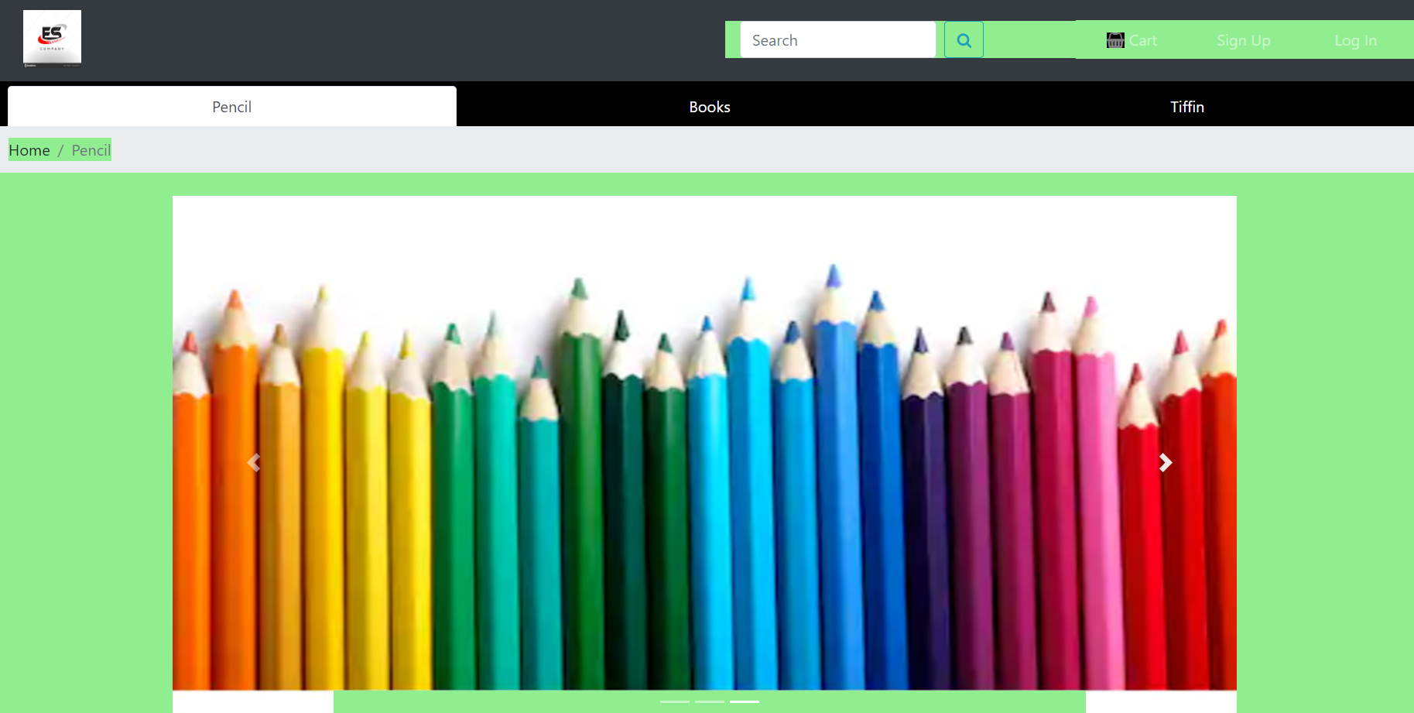

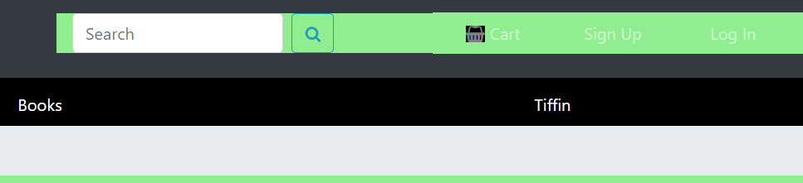

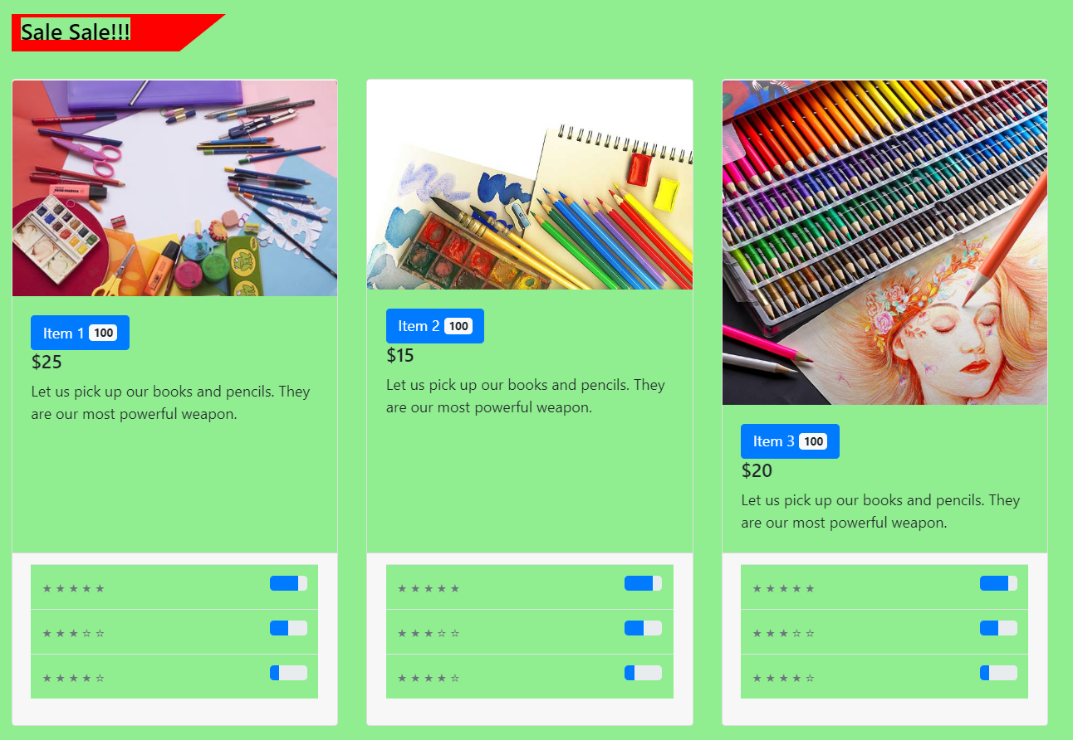

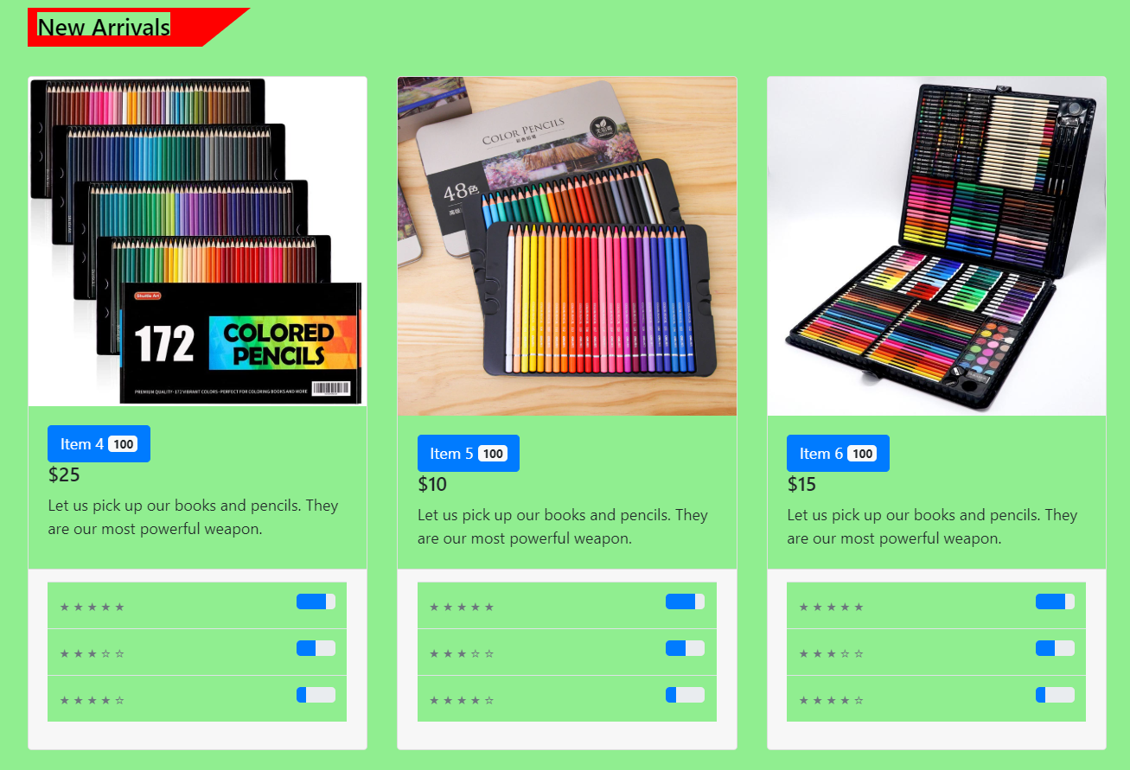

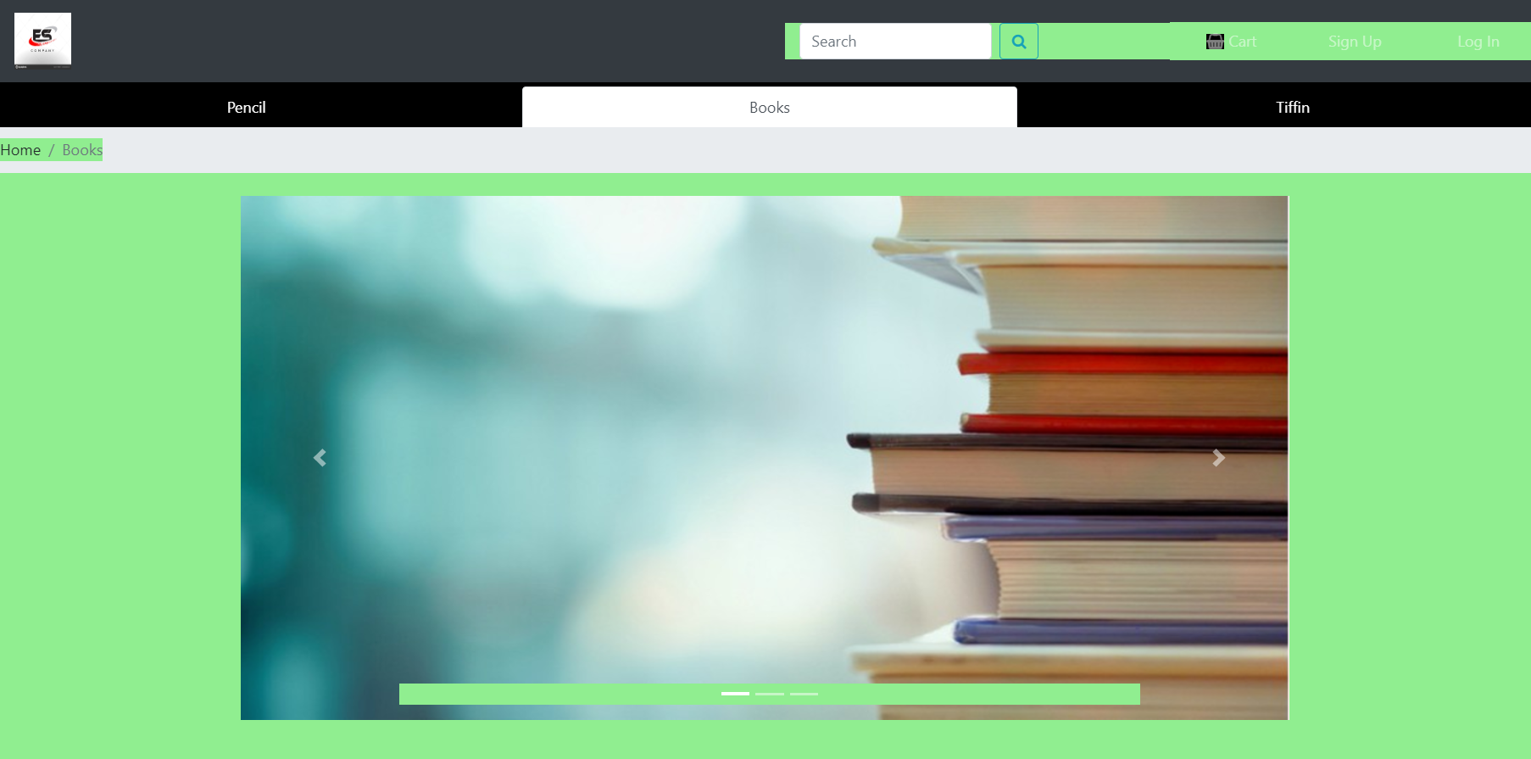

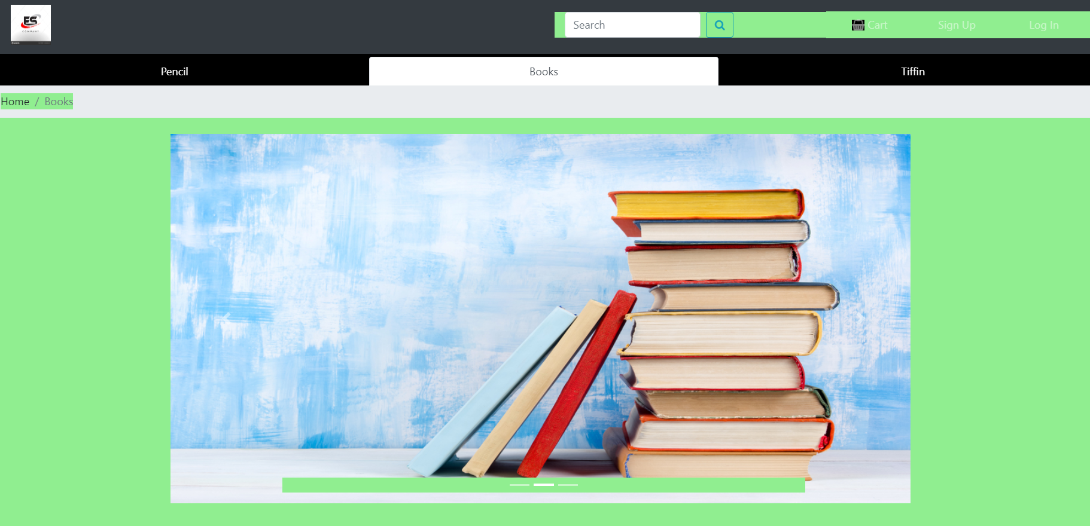

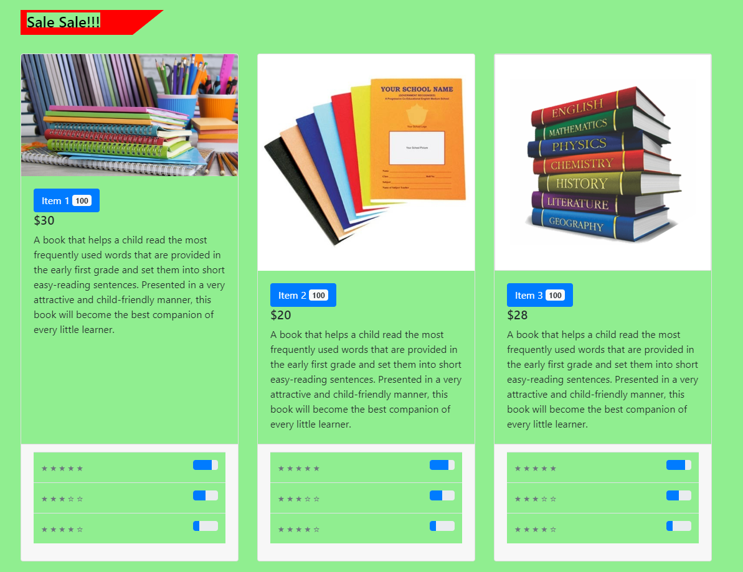

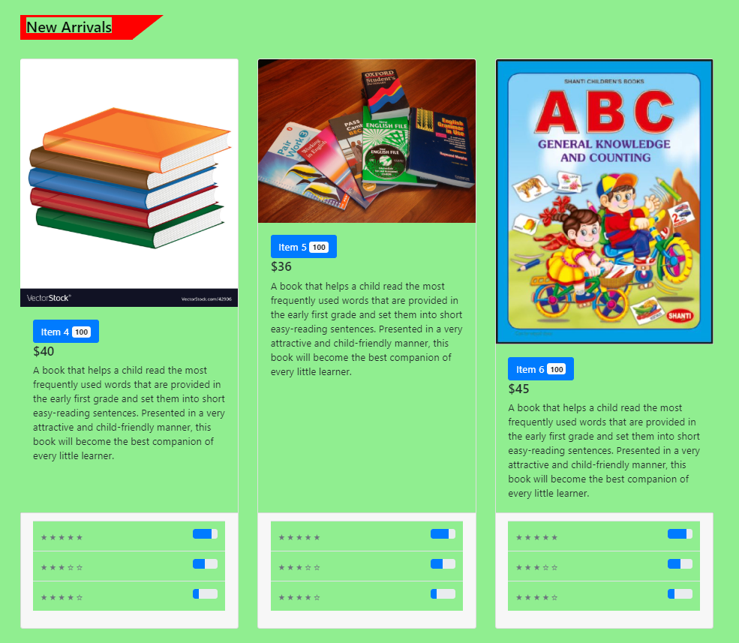

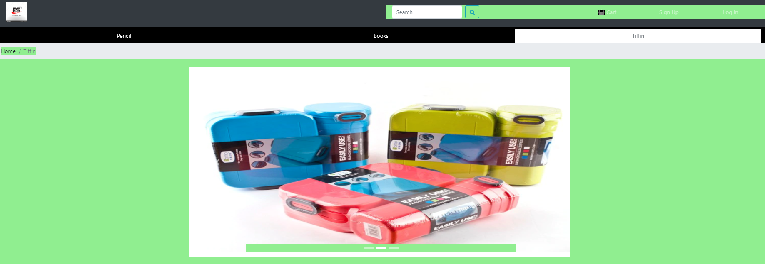

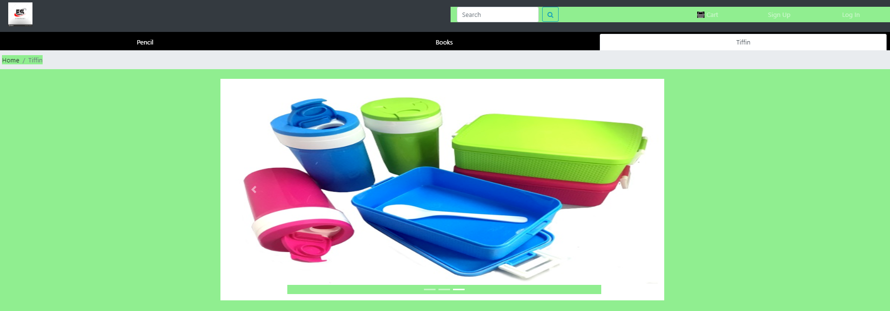



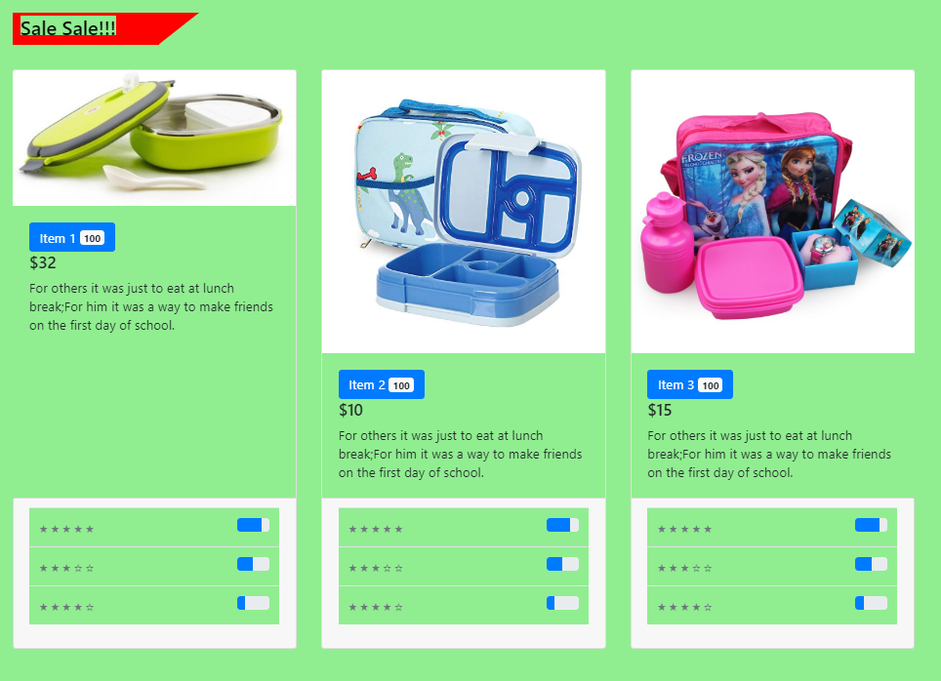

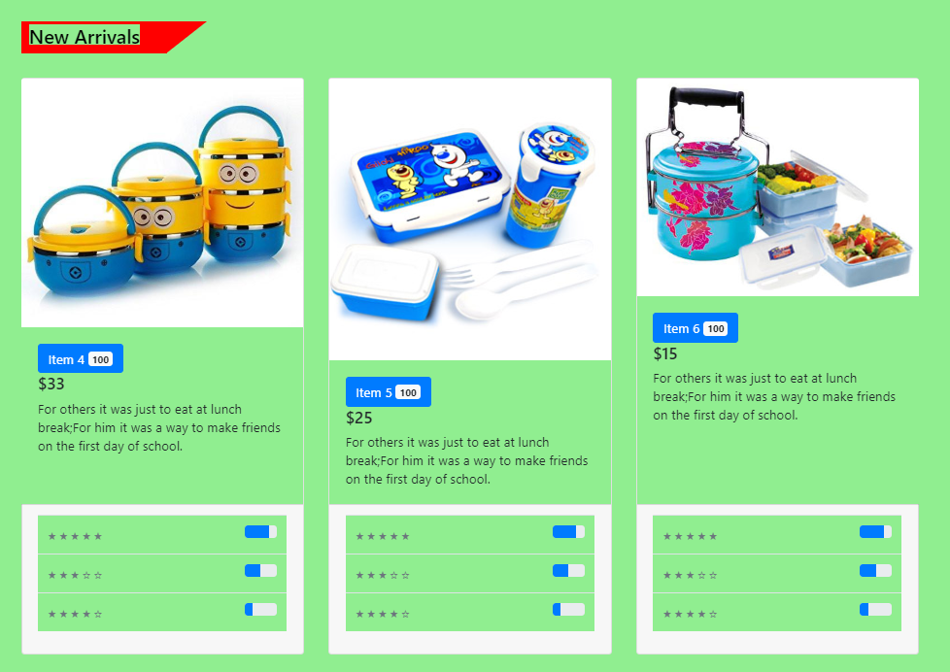

**Conclusion**:

With Bootstrap, you don’t have to reinvent the wheel each time you want to create a new application or website. This front-end framework is packed with multiple features that help developers accomplish their goals without starting from scratch. Templates and themes are built to be responsive from the word go, eliminating the worry of having a site that is not interactive. This allows developers to concentrate on what’s important, which is to build whatever it is that they have in mind.From this experiment we create E-commers website by using Bootstrap.